Formal Lab Report: Unknown B
Hannah Grace Griggs
Partner(s): None
Date Submitted: 11/28/23
Chem 2071 Section Number: 003

Introduction
During this lab, the purpose is to identify the Unknown B compound. By looking at the charts and data provided, this can be accomplished. The charts provided are the Nuclear Magnetic Resonance (NMR) Sample, the Fourier Transform Infrared (FTIR) Sample, and the Mass Spectrometry (MS) Sample. From the information in these graphs, the goal is to be able to identify the name of Unknown Compound B along with its chemical structure. This is an applicable skill because it is fast, requires only a small amount of material, and is nondestructive.
Body
NMR:
Nuclear Magnetic Resonance (NMR) is a technique used to help reveal placement of atoms within a molecule. The main idea behind NMR is that many nuclei have spin, and all nuclei are electrically charged. Re-orientation occurs with absorption of electromagnetic radiation in the radio frequency region which depends on the isotopic nature of the nucleus. The resonance frequency of each NMR-active nucleus depends on its chemical environment. From this, NMR spectra provide information about individual functional groups present in the sample and how they connect to nearby nuclei in the same molecule. NMR spectroscopy is one of the most important methods to identify molecular structures.
FTIR:
Fourier Transform Infrared Spectrometer is the most common form of infrared spectroscopy. During this, infrared radiation passes through a sample and is recorded. Because different molecules with their different structures produce different spectra, the spectra can be used to identify and distinguish among molecules. The spectra are unique and are differential. This method of infrared spectroscopy is preferred for several reasons. One being that it doesn’t destroy the sample. Another being that it is significantly faster than other technologies. Also, it is much more precise.
MS:
Mass spectrometry is a useful tool for measuring the mass-to-charge ratio of one or more molecules present in a sample. The measurements can often be used to calculate the exact molecular weight of the sample components. Every mass spectrometer consists of at least an ionization source, a mass analyzer, and an ion detector system. First, molecules are converted to gas-phase ions so that they can be moved about and manipulated by external electric and magnetic fields. Once ionized, the ions are sorted and separated according to mass-to-charge ratios. The separated ions are then measured and sent to a data system where the ratios are stored together along with their relative abundance. A mass spectrum is formed of the ratios of the ions present in the sample, and heights of the peaks represent the relative abundance of the various components in the sample.
Data
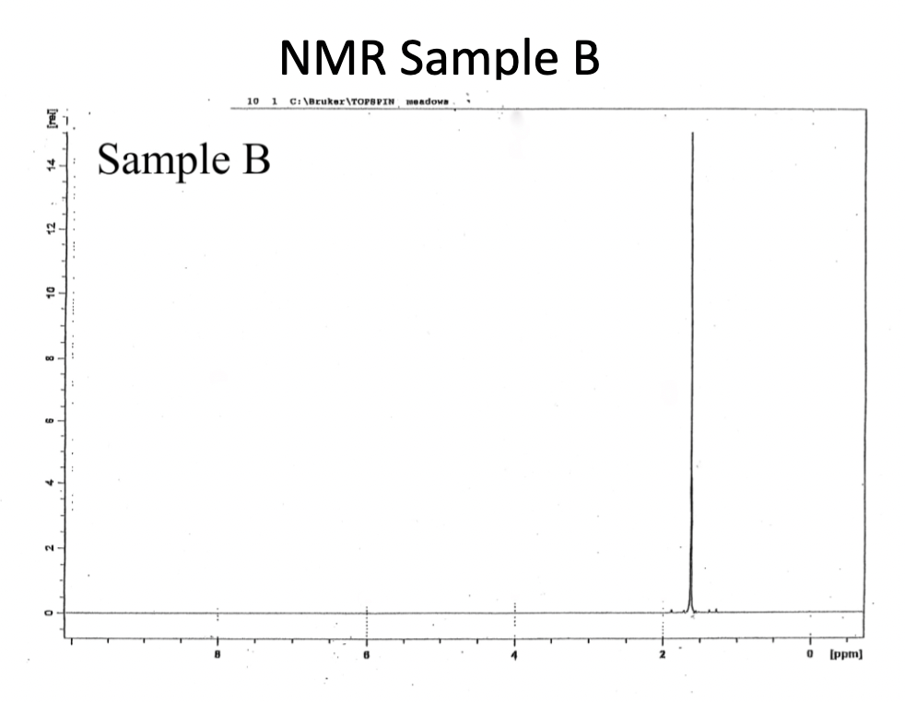

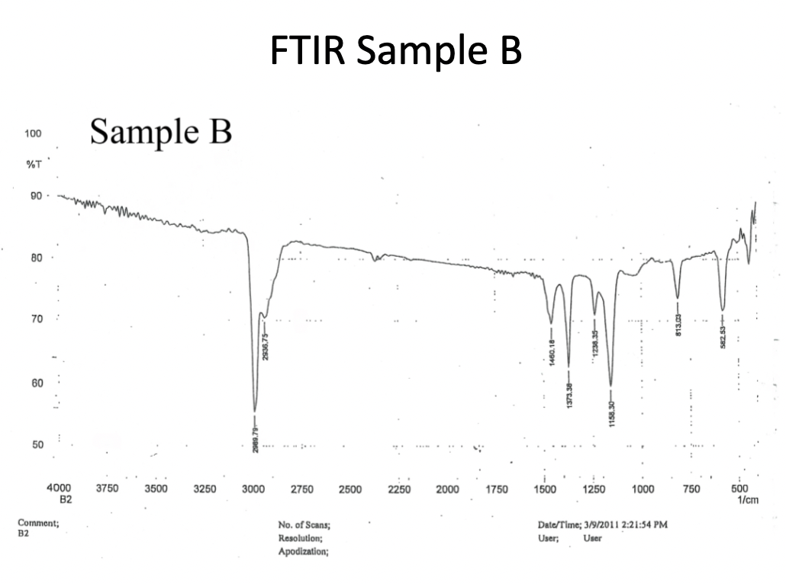
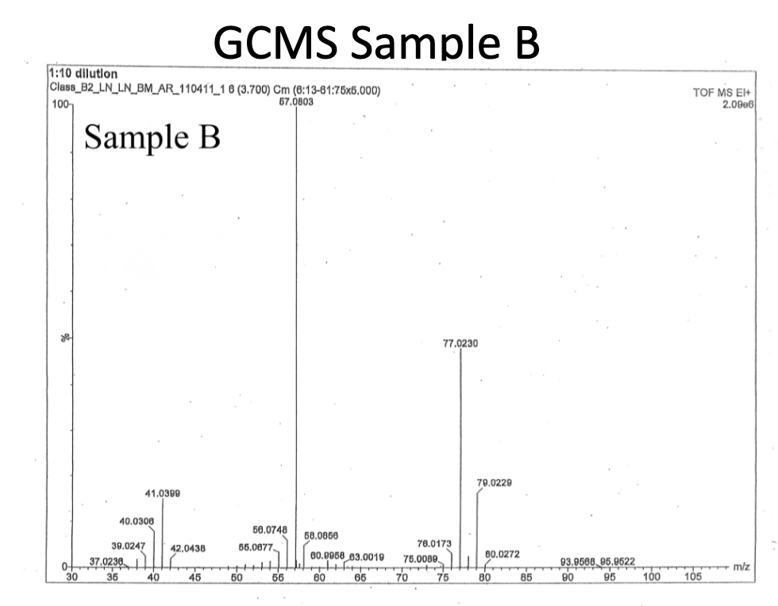

Analysis
NMR:
From the NMR data, it is clear there are no molecules connected to hydrogen in the beta position. This is shown by the singlet present. The total number of molecules in the compound is still undetermined. If there is more than one molecule that has no beta hydrogens, there must be symmetry within the unknown. This means that the singlet is representing all the hydrogens present in the molecule.
FTIR:
The data from this graph displays that there are three carbons present. On the x-axis, the range from 1000-1500 1/cm determines this. Based on the 2800-3200 range, there is no indication of the presence of an amine or alcohol. An alcohol would be identified by a drastic dip in the region, while an amine would be identified by a unique curve in the region. The 1600-1850 region give indication of no double bonds within the molecule. Carbon to oxygen double bonds are identified by a large and narrow dip in the graph, while a carbon to carbon double bond is identified by small repeating curves. This leads to the conclusion of no double bonds within the molecule.
MS:
The GCMS graph has its highest peak at 57 m/z meaning that there must be four carbons in the unknown molecule. This is concluded by simple calculations including four times twelve. This equals forty-eight. Then, nine is added to forty-eight to account for the nine hydrogens. This explains why the peak is at 57 m/z. It is also important to acknowledge the peaks at 77 m/z and 79 m/z. This tells us that a chlorine is present in the unknown compound by observing these smaller peaks.
Conclusion
My conclusion is that Unknown B is 2-chloro-2-methylpropane. The NMR displays specific placement and connectivity. This determined no alpha hydrogens were able to be affected by the spinning of beta hydrogens. The FITR displays that there is a three-carbon backbone along with no functional groups. Lastly, the GCMS displays four total carbons in the compound along with a chlorine. Combining this data, Unknown B can be identified as 2-chloro-2-methylpropane.
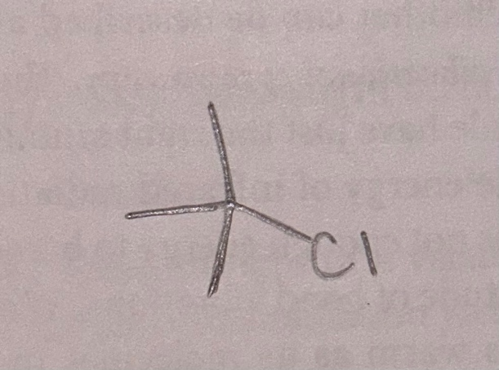
References
H McNeil. Extraction. CHEM 2081 Organic Chemistry II Lab Manual. Macmillan Learning Curriculum Solution: Plymouth, 2023.

